Appendix V. Adjudicated Gold Reference Construction and Reliability Documentation
- Purpose and scope
This appendix documents how the adjudicated gold reference set was constructed and audited as the reliability anchor for the text-based measurement pipeline. Whereas Appendix IV reports the manual ACOS coding protocol itself, including admissible evidence rules, category boundaries, span conventions, sentiment anchors, and exclusion rules, this appendix focuses on the operational construction of the independent reference standard under that protocol. It covers the gold-reference sampling design, the review-level separation from the weak-labelling stream, independent double annotation by the two authors, component-wise inter-annotator agreement documentation, reconciliation and AI-assisted adjudication, and post-adjudication audit evidence on source composition, category distribution, and sentiment distribution. The adjudicated gold reference is treated as an external benchmark rather than as an extension of the weak-labelled corpus: its purpose is to provide a stable, auditable, and inspectable anchor for weak-label calibration, extractor evaluation, and reliability documentation, while reducing the risk of circular validation, data leakage, and selection-induced optimism during later model development and performance reporting (Cawley & Talbot, 2010).
- Gold-reference sampling design
Figure 1 summarises the gold-reference sampling workflow used to prepare the review set for independent ACOS annotation and subsequent adjudication. The gold-reference sampled reviews were drawn from the same full review corpus used in the case study, but the sampling procedure first separated the gold-sampling pool from reviews already used in the weak-labelling stream. This separation was necessary because the adjudicated gold reference was intended to function as an independent benchmark for weak-label calibration, extractor evaluation, and reliability documentation; allowing the same review records to enter both weak supervision and gold-reference construction would risk leakage, circular validation, and selection-induced optimism in later performance estimates (Cawley & Talbot, 2010; Kapoor & Narayanan, 2023). Four full city-level translated review datasets were loaded and tagged by city, yielding 217,139 review observations in total. The script then collected REVIEW_ID values from the four weak-labelled sample files and removed those records from the full review population before any gold-reference sampling was conducted. This step excluded 21,715 previously weak-labelled review observations and produced a candidate pool that was review-level disjoint from the weak-labelled sample. The separation is therefore defined at the review-record level: reviews used for weak labelling were not eligible for gold-reference sampling. The script implements this by collecting weak-labelled REVIEW_IDs and filtering them out before preparing the sampling frame.
After weak-label exclusion, the script allocated a fixed target of 1,500 reviews per city, for an intended gold-reference sample of 6,000 reviews. Within each city, restaurants were stratified by restaurant size, measured by the number of available reviews per restaurant. City-specific quartiles were used to classify restaurants into small, medium, and large strata. The target allocation was 60% from small restaurants, 35% from medium restaurants, and 5% from large restaurants, with large restaurants capped at 100 reviews per restaurant. If a city-level stratum was underfilled, additional reviews were sampled from the remaining city pool. This design was intended to improve diversity and avoid over-representation of a small number of very large restaurants while retaining restaurant-size variation in the gold-reference sample.
The resulting output contained 6,000 sampled reviews, with balanced city coverage of 1,500 reviews from each of the four city datasets. The sampled reviews were then retained as the input set for independent ACOS annotation and subsequent adjudicated gold-reference construction. In the output file, the 6,000 sampled reviews cover 296 unique restaurants. The final review-level distribution by restaurant-size stratum was 3,368 small-restaurant reviews, 2,146 medium-restaurant reviews, and 486 large-restaurant reviews. These realised counts reflect the restaurant-level sampling procedure, the large-restaurant cap, and the underfill top-up step, rather than a simple independent random draw of review records.
------------------Insert Figure 1 around here------------------
- Manual annotation
Two manual annotators independently applied the same ACOS coding protocol described in Appendix IV. The two annotators were the authors of the study, both of whom were directly involved in developing the construct blueprint, facet definitions, and manual coding protocol. This ensured that the annotation task was carried out by coders with substantive knowledge of the measurement objective, the PFQ/PEQ/PSQ construct structure, and the intended use of ACOS tuples as admissible textual observations. To reduce individual coder bias, the two annotators applied the protocol independently before reconciliation and adjudication.
For each review, annotators identified admissible aspect-category-opinion-sentiment tuples in the format [ASPECT, CATEGORY, OPINION, SENTIMENT], consistent with the ACOS representation proposed in aspect-category-opinion-sentiment extraction research (Cai et al., 2021). The task required the annotators to identify not only the broad meaning of each review but also the specific text-grounded evidence units that could support later construct scoring. This is important because, in the present framework, the annotated tuple is not merely a text-mining label but a micro-level observation unit within a broader measurement design.
Because the ACOS tuple is used as the micro-level observation unit in the measurement framework, reliability was documented at multiple levels rather than through one omnibus score. Category agreement describes whether annotators mapped evidence to the same construct facet. Aspect-span and opinion-span agreement describe whether annotators localised comparable textual evidence. Sentiment agreement describes whether annotators assigned similar evaluative intensity once evidence had been identified. This multi-component reporting strategy is consistent with guidance on inter-coder agreement in computational linguistics, where agreement may differ across segmentation, classification, and labelling decisions (Artstein & Poesio, 2008), and with text-based measurement frameworks that treat reliability as part of the full construct-to-score pipeline rather than as a single model-level statistic (Birkenmaier et al., 2024; Low et al., 2025). It is also consistent with a Generalisability Theory perspective, under which disagreement may arise from multiple facets of the measurement process, including evidence selection, span-boundary decisions, category interpretation, and valence-intensity judgement (Brennan, 1992; Cronbach et al., 1972; Shavelson et al., 1989).
- Agreement metrics and reporting rationale
The agreement statistics were selected to reflect the multi-component structure of the ACOS annotation task. In this appendix, the term annotation component refers to the specific part of the manual coding task for which agreement was assessed. Because an ACOS tuple consists of an aspect, a category, an opinion expression, and a sentiment label, inter-annotator agreement cannot be adequately represented by a single omnibus coefficient. Annotators may agree on the construct facet while drawing slightly different span boundaries, or they may identify comparable evidence while assigning different sentiment intensity. For this reason, agreement was reported separately for category assignment, aspect span localisation, opinion span localisation, and sentiment assignment. This component-wise reporting is consistent with computational-linguistic annotation practice, where agreement may depend on segmentation, unit identification, and label assignment rather than on a single closed-set classification decision (Artstein & Poesio, 2008).
Figure 2 provides an illustrative example of how these annotation components relate to the ACOS structure. The example shows that two annotators may recover the same broad evidence units from a review while differing in opinion-span boundaries, such as “absolutely delicious” versus “delicious”, or in sentiment intensity, such as “very positive” versus “positive”. This illustrates why the reliability evidence is decomposed into separate category, span-localisation, and sentiment-assignment components rather than reported as a single exact-match statistic.
------------------Insert Figure 2 around here------------------
Category assignment evaluates whether the two annotators mapped an identified evidence unit to the same predefined construct facet, namely FOOD#QUALITY, SERVICE#GENERAL, or AMBIENCE#GENERAL. This component is central to the measurement design because the category label determines which construct facet later receives the evidence. Since category assignment is a nominal classification task, Cohen’s kappa was used as the primary chance-corrected two-rater agreement coefficient (Artstein & Poesio, 2008; Cohen, 1960). Percent agreement was also reported as a transparent descriptive indicator, but it was not interpreted alone because it does not adjust for chance agreement. Gwet’s AC1 was included as a robustness indicator because Cohen’s kappa can be sensitive to prevalence and marginal-distribution effects, especially when some categories are much more frequent than others (Gwet, 2008; Wongpakaran et al., 2013).
Aspect span localisation evaluates whether the annotators identified comparable textual targets of evaluation. In the ACOS format, the aspect is the object, attribute, dish, service element, or environmental feature being evaluated. Opinion span localisation evaluates whether the annotators identified comparable evaluative expressions, such as the phrase that conveys praise, criticism, neutrality, or diagnostic information. These two components are reported separately because annotators may agree that a review contains food-quality evidence but differ in whether the aspect is marked narrowly as “paella” or more broadly as “the paella dish”, or whether the opinion span is marked as “good” or “very good”. For these span-localisation components, strict and partial F1 scores were reported. Span annotation differs from closed-set category coding because there is no well-defined set of true negative spans. F1-style indicators are therefore appropriate for information-extraction and phrase-localisation tasks, where agreement depends on overlap between extracted textual spans rather than on selecting one label from a fixed set for every possible unit (Hripcsak & Rothschild, 2005). Strict F1 captures exact span-boundary agreement, while partial F1 captures substantive overlap when annotators identify similar evidence but delimit the phrase differently.
Sentiment assignment evaluates whether the annotators assigned the same or similar evaluative intensity to comparable facet-linked evidence. Because the five sentiment labels form an ordered scale, very negative, negative, neutral, positive, and very positive, weighted kappa is more appropriate than a purely nominal coefficient: it distinguishes adjacent disagreements from more severe disagreements across the ordered scale (Cohen, 1968) and gives partial credit when the disagreement is small (Krippendorff, 2011). In the computation used here, sentiment agreement was first summarised at the review-category level rather than at the raw tuple level. Specifically, for each annotator, all sentiment labels within the same REVIEW_ID × CATEGORY cell were aggregated into a majority sentiment; cells with no valid sentiment were coded as none, and tied majorities were resolved as neutral. The two annotators’ review-category sentiment records were then merged, so that each row represented a category-specific sentiment comparison for a given review.
On this basis, two forms of sentiment agreement are reported. The first, sentiment assignment for all merged review-category pairs, is an inclusive diagnostic indicator. It includes all review-category pairs for which at least one annotator identified sentiment-bearing evidence. When one annotator identified a category-specific sentiment and the other did not, the missing side was treated as none. The corresponding weighted kappa therefore uses an extended scale consisting of none plus the five ordered sentiment levels. A disagreement between none and any substantive sentiment is treated as a full mismatch, while disagreements between substantive sentiment levels are weighted according to their ordinal distance. This inclusive coefficient is deliberately conservative because it combines evaluative disagreement with upstream disagreement in whether a review-category evidence unit was identified at all. The accompanying percent agreement reports the proportion of exact matches in this inclusive merged table, including cases where both annotators assigned the same substantive sentiment. For this reason, the inclusive weighted kappa and inclusive percent agreement are retained as diagnostic indicators, but they are not used as the headline evidence for sentiment reliability.
The second, sentiment assignment for co-coded review-category pairs only, is the primary sentiment reliability indicator. It restricts the analysis to review-category pairs for which both annotators assigned a valid sentiment label from the five-level ordered scale, thereby excluding none cases. This conditional version isolates evaluative coding consistency after comparable category-level evidence has been identified by both annotators. The conditional weighted kappa therefore evaluates ordinal agreement in sentiment intensity among co-coded review-category pairs, while the conditional percent agreement reports exact sentiment-label agreement within the same restricted set. This distinction explains why the unconditional weighted kappa is low whereas the conditional weighted kappa is substantially higher: the former reflects both sentiment disagreement and upstream evidence-selection mismatch, while the latter focuses on valence and intensity agreement once both annotators have coded sentiment for the same review-category unit.
The term metric in Table 1 therefore refers to the statistical indicator used to summarise agreement for each annotation component. Kappa-type coefficients were used where the task involved categorical labels, F1-style scores were used where the task involved textual span localisation, and conditional coefficients were used where downstream agreement depended on first aligning comparable evidence units. The coefficients are interpreted using conventional reference ranges only as heuristic guidance. For kappa-type coefficients, values between 0.61 and 0.80 are commonly described as substantial agreement, but such thresholds should not be treated as universal cut-offs because annotation complexity, class prevalence, span granularity, and task design all affect observed agreement (Artstein & Poesio, 2008; Landis & Koch, 1977). The purpose of Table 1 is therefore not to claim that all components satisfy a single universal threshold, but to show where the manual coding protocol was stable, where disagreement mainly arose, and why adjudication was required before freezing the final gold reference.
------------------Insert Table 1 around here------------------
Under this reporting logic, category assignment showed substantial agreement, with Cohen’s kappa = 0.7138, Gwet’s AC1 = 0.7141, and percent agreement = 0.8564. Span localisation showed lower exact-boundary agreement, but partial F1 values were higher than strict F1 values for both aspect spans and opinion spans, indicating that many disagreements concerned boundary delimitation rather than complete disagreement about the relevant evidence. For sentiment, the unconditional coefficients are retained only as diagnostics because they combine true sentiment disagreement with upstream differences in evidence selection and span alignment. The conditional weighted kappa of 0.6897 indicates substantially stronger sentiment agreement once comparable evidence pairs had been identified.
To complement the overall results, Table 2 reports facet-level agreement patterns for the three construct-linked ACOS categories. This breakdown is useful because the difficulty of manual coding may differ across facets. Food-related evidence often involves diverse dish names and sensory descriptions, ambience evidence may involve physical setting and atmosphere descriptions, and service evidence often contains more explicit interpersonal or process-related language. Table 2 should therefore be read as a diagnostic decomposition of the overall reliability evidence rather than as a separate benchmark. The macro average reports the unweighted mean across the three categories, while Table V.2 reports the overall agreement pattern across the full double-annotation output.
------------------Insert Table 2 around here------------------
The facet-level pattern provides further support for the interpretation of the overall results. Category agreement was strongest for SERVICE#GENERAL, where category kappa reached 0.7858 and percent agreement reached 0.8947. This suggests that service-related evidence was comparatively easier to assign consistently, probably because service evaluations often contain explicit references to staff, speed, helpfulness, or interpersonal behaviour. AMBIENCE#GENERAL also showed substantial category agreement, with category kappa = 0.6712 and Gwet’s AC1 = 0.7432. FOOD#QUALITY showed the lowest category kappa, 0.5727, although its percent agreement remained high at 0.8193 and Gwet’s AC1 was 0.6905. This pattern suggests that food-related evidence was still broadly identifiable, but may have involved more variation in aspect granularity, dish references, or sensory expressions.
The sentiment results show the same distinction between unconditional and conditional agreement observed in Table 1. Unconditional sentiment weighted kappa was low across all categories, especially for AMBIENCE#GENERAL. This reflects the fact that unconditional sentiment agreement is affected by upstream tuple selection and span alignment, not only by disagreement about valence. Once evidence pairs were aligned, conditional sentiment weighted kappa increased substantially across all three facets, reaching 0.6473 for FOOD#QUALITY, 0.6774 for AMBIENCE#GENERAL, and 0.7313 for SERVICE#GENERAL. This supports the interpretation that sentiment coding was considerably more stable after comparable evidence units had been identified. Taken together, Table 1 and Table 2 indicate that the manual coding protocol provided meaningful agreement at the construct-facet level, while remaining sufficiently complex to require reconciliation and adjudication before the final gold reference was frozen.
- Reconciliation and AI-assisted adjudication workflow
After the two independent ACOS annotations had been completed, the annotation outputs were compared at the review level to identify cases requiring adjudication. The comparison procedure retained the original review identifier, city subset, review text, Annotator 1 ACOS annotations, Annotator 2 ACOS annotations, and diagnostic information about matched and unmatched tuples. Cases involving disagreement, missing evidence, structural mismatch, or otherwise unresolved annotation outputs were then passed to an AI-assisted adjudication workflow.
The AI-assisted adjudicator was used as a constrained adjudication support mechanism, not as an unconstrained re-labelling system. The adjudication script invoked the GPT-5 model through the ChatGPT API and processed only records that had been flagged for adjudication after independent double annotation. For each flagged review, the adjudicator received a structured prompt containing the review identifier, city, full review text, indexed ACOS outputs from Annotator 1 and Annotator 2, and the allowed category and sentiment values. The system prompt framed the model as an expert ACOS adjudicator whose task was to resolve disagreements between the two annotators and produce a single gold-style annotation. Crucially, the prompt stated that the review text was the only source of truth, prohibited unsupported aspects or opinions, required every final ACOS item to be supported by verbatim evidence spans, and instructed the adjudicator to prefer conservative selection or merging of existing annotator items over adding new ones. This design is consistent with the methodological view that LLM-supported annotation should be constrained by explicit coding rules, transparent prompting, and human verification rather than treated as automatic ground truth generation (Demszky et al., 2023; Törnberg, 2024).
The system prompt used for AI-assisted adjudication was as follows:
"You are an expert ACOS adjudicator. Resolve disagreements between two annotators (Agent1 and Agent2) "
"and produce a single, final gold-style ACOS annotation for the given review. "
"The review text is the only source of truth. Do not invent aspects/opinions not supported by the text. "
"Evidence-first: every final ACOS must include evidence spans copied verbatim from the review. "
"Be conservative: prefer selecting/merging existing items over adding new items. "
"Return JSON only."
The adjudicator output was constrained to produce one review-level adjudication record. Each output contained a final ACOS list, an action log, quality flags, an overall confidence score, and a human-review indicator. Each final ACOS item included a final index, aspect, category, opinion, sentiment, nullable error field, evidence span list, and source label. The source label indicated whether the final item came from Annotator 1, Annotator 2, a merge of both annotators’ annotations, or a new AI-assisted addition. The action log provided an audit trail linking the original indexed annotator items to the final indexed ACOS items through keep, drop, merge, modify, add, or deduplicate actions. In this way, the workflow preserved both the final adjudicated reference annotation and a traceable record of how that final annotation was derived.
- Adjudicated gold outputs
The reconciliation and AI-assisted adjudication workflow yielded a frozen adjudicated gold reference corpus in which final ACOS observations were stored at the review level. Based on the corrected adjudicated gold file used in the present analysis, the final corpus contains 5,431 review-level records and 15,635 adjudicated ACOS observations in total.
At the review level, 4,959 reviews yielded at least one final adjudicated ACOS observation, whereas 472 reviews yielded an empty final ACOS list. This means that approximately 91.3% of the adjudicated reviews contributed at least one retained gold-standard observation. On average, the final adjudicated corpus contains 2.88 ACOS observations per review, or 3.15 ACOS observations per non-empty review. The review-level distribution therefore indicates that the adjudicated gold set contains substantial multi-observation evidence rather than only single-label review summaries.
Coverage was also distributed across the four city-level subsets. The final adjudicated gold corpus contains 1,361 reviews from Barria Plaza (Bilbao), 1,349 from Espainia Plaza (Vitoria-Gasteiz), 1,371 from Konstituzio Plaza (San Sebastián), and 1,350 from Plaza del Castillo (Pamplona). In tuple terms, these subsets contributed 4,151, 3,803, 4,107, and 3,574 adjudicated ACOS observations, respectively. The resulting reference set is therefore balanced across the four sampled localities and is not dominated by a single city subset.
At the category level, the final adjudicated ACOS observations are distributed across all three pre-specified construct facets. FOOD#QUALITY accounts for 7,728 observations (49.4%), SERVICE#GENERAL for 5,108 observations (32.7%), and AMBIENCE#GENERAL for 2,799 observations (17.9%). This distribution indicates that the adjudicated reference set preserves broad construct-facet coverage while also reflecting the greater frequency with which food-related evaluations appeared in the sampled restaurant reviews. At the sentiment level, positive evaluations account for 7,245 observations (46.3%), very positive evaluations for 4,979 observations (31.8%), negative evaluations for 2,407 observations (15.4%), very negative evaluations for 640 observations (4.1%), and neutral evaluations for 364 observations (2.3%). In aggregate, positive and very positive observations account for 78.2% of the final adjudicated ACOS observations, whereas negative and very negative observations account for 19.5%. This sentiment distribution is consistent with the generally positive orientation of online restaurant reviews while still retaining a substantial number of negative and very negative evidence units for reliability anchoring and extractor evaluation.

Reference
Artstein, R., & Poesio, M. (2008). Inter-Coder Agreement for Computational Linguistics. Computational Linguistics, 34(4), 555–596. https://doi.org/https://doi.org/10.1162/coli.07-034-R2
Birkenmaier, L., Lechner, C., & Wagner, C. (2024). ValiText-a Unified Validation Framework for Computational Text-Based Measures of Social Constructs. https://doi.org/https://doi.org/10.48550/arXiv.2307.02863
Brennan, R. L. (1992). Generalizability Theory. Educational Measurement: Issues and Practice, 11, 27–34. https://doi.org/https://doi.org/10.1111/j.1745-3992.1992.tb00260.x
Cai, H., Xia, R., & Yu, J. (2021). Aspect-Category-Opinion-Sentiment Quadruple Extraction with Implicit Aspects and Opinions. Proceedings of the 59th Annual Meeting of the Association for Computational Linguistics and the 11th International Joint Conference on Natural Language Processing (Volume 1: Long Papers), 340–350. https://doi.org/10.18653/v1/2021.acl-long.29
Cawley, G. C., & Talbot, N. L. C. (2010). On Over-fitting in Model Selection and Subsequent Selection Bias in Performance Evaluation. Journal of Machine Learning Research, 11, 2079–2107.
Cohen, J. (1960). A Coefficient of Agreement for Nominal Scales. Educational and Psychological Measurement, 20(1), 37–46. https://doi.org/https://doi.org/10.1177/001316446002000104
Cohen, J. (1968). Weighted kappa: Nominal scale agreement provision for scaled disagreement or partial credit. Psychological Bulletin, 70(4), 213–220. https://doi.org/https://doi.org/10.1037/h0026256
Cronbach, L. J., Gleser, G. C., Nanda, H., & Rajaratnam, N. (1972). Coefficient Alpha and the Internal Structure of Tests.
Demszky, D., Yang, D., Yeager, D. S., Bryan, C. J., Clapper, M., Chandhok, S., Eichstaedt, J. C., Hecht, C., Jamieson, J., Johnson, M., Jones, M., Krettek-Cobb, D., Lai, L., JonesMitchell, N., Ong, D. C., Dweck, C. S., Gross, J. J., & Pennebaker, J. W. (2023). Using large language models in psychology. Nature Reviews Psychology, 2(11), 688–701. https://doi.org/10.1038/s44159-023-00241-5
Gwet, K. L. (2008). Computing inter-rater reliability and its variance in the presence of high agreement. British Journal of Mathematical and Statistical Psychology, 61(1), 29–48. https://doi.org/10.1348/000711006X126600
Hripcsak, G., & Rothschild, A. S. (2005). Agreement, the F-measure, and reliability in information retrieval. Journal of the American Medical Informatics Association, 12(3), 296–298. https://doi.org/10.1197/jamia.M1733
Kapoor, S., & Narayanan, A. (2023). Leakage and the reproducibility crisis in machine-learning-based science. Patterns, 4(9). https://doi.org/10.1016/j.patter.2023.100804
Krippendorff, K. (2011). Agreement and information in the reliability of coding. Communication Methods and Measures, 5(2), 93–112. https://doi.org/10.1080/19312458.2011.568376
Landis, J. R., & Koch, G. G. (1977). The Measurement of Observer Agreement for Categorical Data. Biometrics, 33(1), 159–174. https://doi.org/https://doi.org/10.2307/2529310
Low, D. M., Mair, P., Nock, M. K., & Ghosh, S. S. (2025). Text Psychometrics: Assessing Psychological Constructs in Text Using Natural Language Processing. https://doi.org/https://doi.org/10.31234/osf.io/9rdux_v4
Shavelson, R. J., Webb, N. M., & Rowley, G. L. (1989). Generalizability Theory Motivation for Generalizability Theory. American Psychologist, 44(6), 922–932. https://doi.org/https://doi.org/10.1037/0003-066X.44.6.922
Törnberg, P. (2024). Best Practices for Text Annotation with Large Language Models. https://doi.org/https://doi.org/10.48550/arXiv.2402.05129
Wongpakaran, N., Wongpakaran, T., Wedding, D., & Gwet, K. L. (2013). A comparison of Cohen’s Kappa and Gwet’s AC1 when calculating inter-rater reliability coefficients: a study conducted with personality disorder samples. BMC Medical Research Methodology, 13(61), 1–7. https://doi.org/https://doi.org/10.1186/1471-2288-13-61

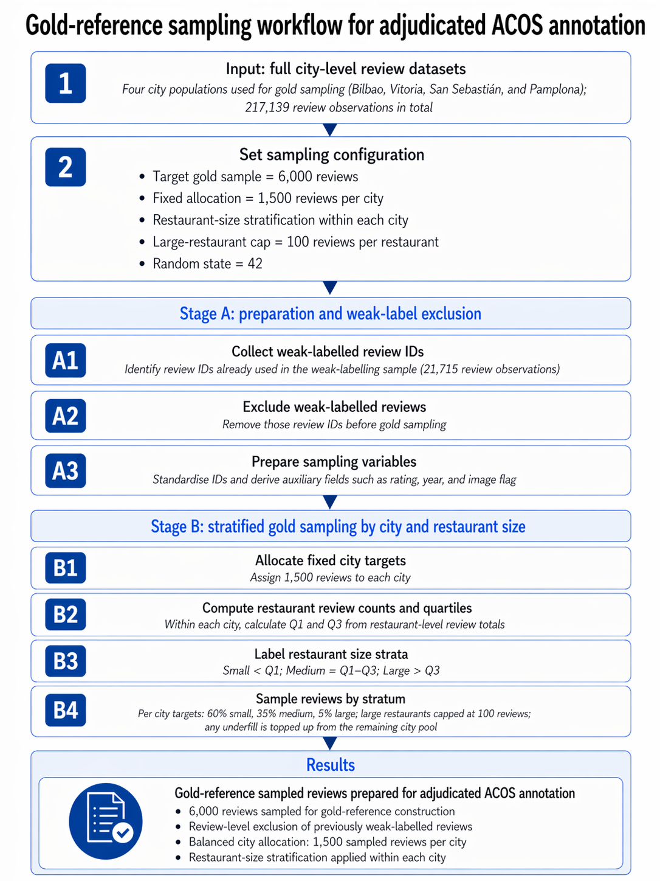
Figure 1 Gold-reference sampling workflow for adjudicated ACOS annotation.

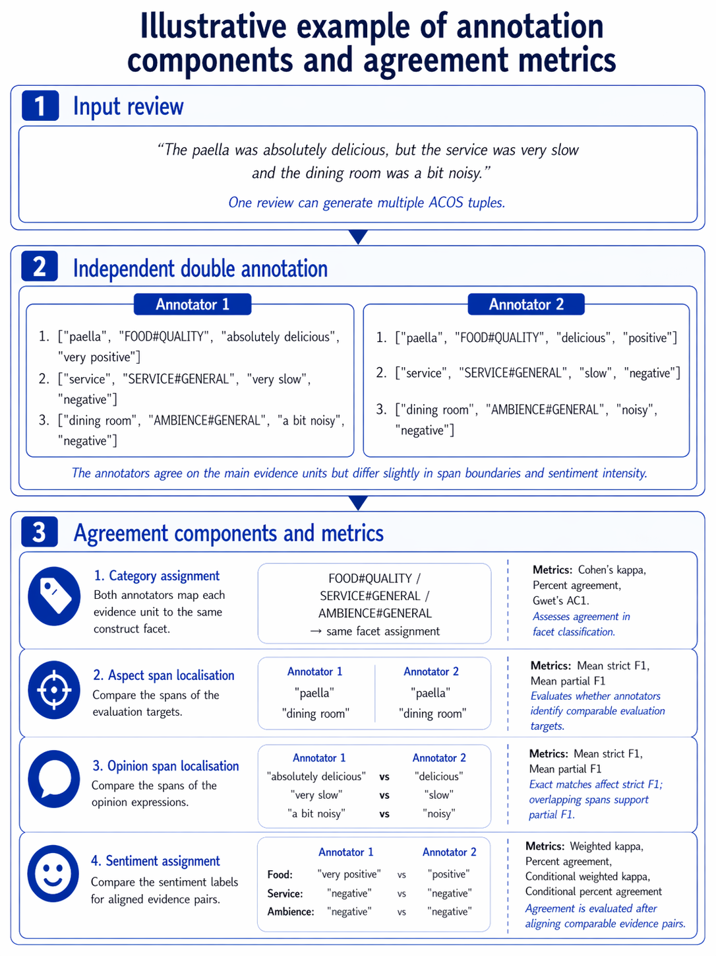
Figure 2 Illustritive example of annotation components and agreement metrics.

Annotation component | Metric | Value | Interpretation in this appendix
Category assignment | Cohen’s kappa | 0.7138 | Primary chance-corrected indicator for nominal facet assignment.
Category assignment | Percent agreement | 0.8564 | Descriptive agreement; reported with chance-corrected coefficients.
Category assignment | Gwet’s AC1 | 0.7141 | Robustness indicator for nominal agreement under possible prevalence effects.
Aspect span localisation | Mean strict F1 | 0.5884 | Exact span-boundary agreement.
Aspect span localisation | Mean partial F1 | 0.6642 | Substantive span-overlap agreement.
Opinion span localisation | Mean strict F1 | 0.6032 | Exact opinion-phrase boundary agreement.
Opinion span localisation | Mean partial F1 | 0.6870 | Substantive opinion-span overlap agreement.
Sentiment assignment (all evidence pairs) | Weighted kappa | 0.1397 | Diagnostic only; affected by upstream tuple and span mismatch.
Sentiment assignment (all evidence pairs) | Percent agreement | 0.4121 | Diagnostic only; not used as the headline sentiment reliability indicator.
Sentiment assignment (aligned evidence pairs only) | Conditional weighted kappa | 0.6897 | Primary sentiment reliability indicator after evidence alignment.
Sentiment assignment (aligned evidence pairs only) | Conditional percent agreement | 0.5404 | Descriptive conditional sentiment agreement.
Table 1 Overall inter-annotator agreement under manual annotation.
Category | Category kappa | Category agreement | Gwet AC1 | Unconditional sentiment weighted kappa | Conditional sentiment weighted kappa | Conditional sentiment agreement
FOOD#QUALITY | 0.5727 | 0.8193 | 0.6905 | 0.1241 | 0.6473 | 0.5469
AMBIENCE#GENERAL | 0.6712 | 0.8553 | 0.7432 | 0.0105 | 0.6774 | 0.5327
SERVICE#GENERAL | 0.7858 | 0.8947 | 0.7935 | 0.2639 | 0.7313 | 0.5365
Macro average | 0.6766 | 0.8564 | 0.7424 | 0.1328 | 0.6853 | 0.5387
Table 2 Facet-level agreement patterns for category and sentiment coding.

